Paper Title: Preparations of Papers for the IJCRT Journal
The Title should be Centre Align font size 14 bold Times New Roman

1st Author Name
Name of Institution/Department, City, Zip Code, Country
E-mail: first.author@hostname1.org
2nd Author Name
Name of Institution/Department, City, Zip Code, Country
E-mail: second.author@hostname2.org
Corresponding author: author name (author email)
Received: Date Month, Year; Accepted: Date Month, Year; Published: Date Month, Year
(Font: Times New Roman/ Size 10 / Center)
Abstract: This document provides the layout of articles that must be submitted for publication in print and electronic editions of the IJCRT Journal. The abstract should be at least 150-250 words. Do not use abbreviations or equations in the abstract.
Index Terms: Leave one line after the Abstract and write your Keywords or/and Key phrases (4-7 words or/and phrases, separated via way of means of a comma).

INTRODUCTION
Your goal is to simulate the normal appearance of the Journal of the IJCRT article. Please follow these instructions.

1.1. Full-Sized Papers
Paper size: prepare your CR paper in full-size format, on A4 paper (210 x 297 mm, 8.27 x 11.69 in). Margins: top = 28mm (1.20 in), bottom, left and right = 18 mm (0.70 in).
Type and font sizes: Follow the type sizes specified in Table I. To aid in type size estimates, 1 point is equal to approximately 0.36 mm. Times New Roman should be the main font of the text. The paper should be evenly spaced.
For Abstract and Index Terms, no first-line indentation. Alignment: left and right-justify your columns. Left-Aligned your table captions, and figure captions. Center-justify your tables and figures. Use automatic hyphenation and check the spelling. Digitize or paste down figures.
Table 1. Type Sizes for Papers
Type size (pts.) | Appearance
 | Regular | Bold | Italic
09 | Table captions, a table superscripts
10 | Section titles, tables, table names, first letters in table captions, figure captions, footnotes, text subscripts, and superscripts | For Heading and Subheadings
10 | References, authors’ biographies
10 | Author First Name, Last Name | Author Name
09 | Authors’ affiliations
14 | Paper title | Title

Section headings: each major section begins with a Heading in 12-point bold Times New Roman Font Left-Aligned in columns and Roman-numbered (except ACKNOWLEDGMENTS and REFERENCES), followed by a period, two spaces, and every first letter of a word (except prepositions and pronouns) must be capitalized. the other is lowercase. Subtitles: must be 10 points, bold, left-aligned, and numbered with letters (1.1, 1.2, …), followed by a period, two spaces, and a title starting with a capital letter for each word.

Helpful Hints

2.1. Figures and Tables
- Figures and tables should be placed in the middle of a page.
- Figure captions should be aligned to the left of the figures, while table captions should be aligned to the right of the table. Figures and tables should not be placed before their first mention in the text.
- Even at the start of a sentence, use the shorthand "Fig. 1."

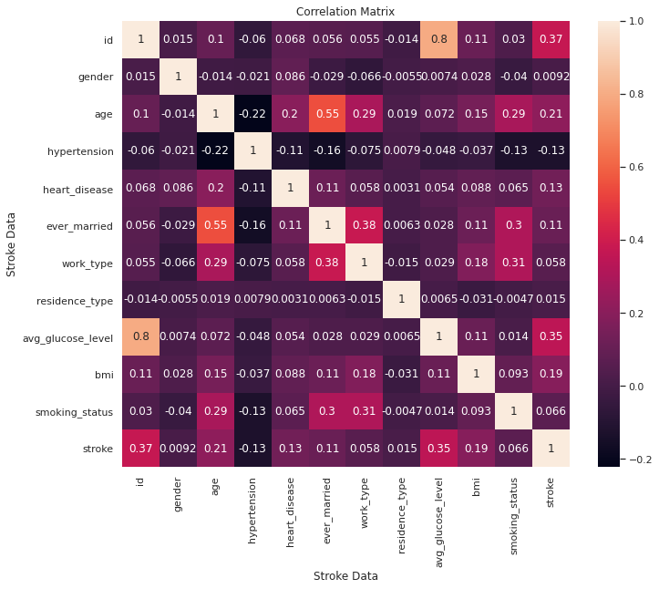
Fig.1. Correlation Matrix
- Use words rather than symbols to create axis labels. Axes should not be labeled solely with units. Axes should not be labeled with a quantity-to-unit ratio. Figure labels should be in 9-point type to make them readable.

2.2. Aditional Information

Number the citations consecutively in square brackets [1]. There are no punctuation marks after the square brackets [2]. "Ref. [3] at the beginning of the sentence" or "Reference [3]". Name all authors. If you have more than 4 authors, use "et al.". Unpublished works should be reported as "unpublished", even if submitted for publication [4]. Works that are approved for publication are cited as "in print" [5].

2.3. Footnotes

Superscripts 1, 2, ... Each footnote is numbered individually. Place the actual footnote at the end of the quoted column, like this column. See the footnote on the first page for an example.

2.4. Abbreviations and Acronyms
- Abbreviations and acronyms are defined when they are first used in the text, even after they are defined in the abstract. Do not use abbreviations in the title unless it is unavoidable.

2.5. Equations
- The equation should be centered in the column. Line spacing should be set before and after the paragraph description of the line containing the equation. If your number the equations after the equation numbers in parentheses as in (1), the height will be the same as the right margin. Italicized Roman symbols for sets and variables. There are no Greek symbols. If the equation is part of a sentence, underline the equation with a comma or period.

(a + b)²= (a + b) (a + b) (1)

The equation symbol must be defined before or immediately after the equation is displayed. Use "(1)" instead of "expression". (1) "or" formula (1) ". However, the beginning of the sentence is excluded. "Equation (1) is ..."

2.6. Other recommendations

Use either SI (MKS) or CGS as the primary unit. (SI credits are recommended.) If English is not your native language, ask an English-speaking colleague to proofread. Do not add the page number.

Acknowledgment
The authors wish to thank A, B, and C. This work was supported in part by a grant from XYZ.

References
- G. O. Young, “Synthetic structure of industrial plastics,” in Plastics, 2nd ed., vol. 3, J. Peters, Ed. New York, NY, USA: McGraw-Hill, 1964, pp. 15–64.
- W.-K. Chen, Linear Networks and Systems. Belmont, CA, USA: Wadsworth, 1993, pp. 123–135.
- R. Fardel, M. Nagel, F. Nuesch, T. Lippert, and A. Wokaun, “Fabrication of organic light-emitting diode pixels by laser-assisted forward transfer,” Appl. Phys. Lett., vol. 91, no. 6, Aug. 2007, Art. no. 061103.
- J. Zhang and N. Tansu, “Optical gain and laser characteristics of InGaN quantum wells on ternary InGaN substrates,” IEEE Photon. J., vol. 5, no. 2, Apr. 2013, Art. no. 2600111.
- S. Azodolmolky et al., Experimental demonstration of an impairment aware network planning and operation tool for transparent/translucent optical networks,” J. Lightw. Technol., vol. 29, no. 4, pp. 439–448, Sep. 2011.

Authors’ Profiles
Author 1st (first-last name) Other authors can add biography and photos to the end of regular articles. If you have a photo, you need to crop it to a width of 25mm and a height of 30mm. The first paragraph can include the location and date of birth (first location, then date). The following is the author's educational background. Degrees should be listed along with degree type, discipline, institution, city, state or country, and year of the degree. The author`s major field of study should be lowercased. Try to list up to 3 books or published articles. Personal hobbies should not be included in the biography.

Author 2nd (first-last name) includes the biography here.

